NAME: KAVITAPU SWARNA VARSHINI
REG.NO: 192324081
DATE: 14-07-2026

Write a python program for Minimax Algorithm for Gaming
AIM: To write a Python program to implement the Minimax Algorithm for decision-making in a two-player game.
ALGORITHM:
- Represent the game tree with possible moves and their scores.
- Define the maximizing and minimizing players.
- Recursively evaluate all possible moves using the Minimax algorithm.
- Choose the move with the best score for the maximizing player.
- Display the optimal score obtained.
CODE:
scores = [3, 5, 2, 9]

def minimax(depth, node, isMax):
if depth == 2:
return scores[node]

if isMax:
return max(minimax(depth + 1, node * 2, False),
minimax(depth + 1, node * 2 + 1, False))
else:
return min(minimax(depth + 1, node * 2, True),
minimax(depth + 1, node * 2 + 1, True))

print("Optimal Value:", minimax(0, 0, True))
OUTPUT:
Optimal Value: 3
IMAGE:
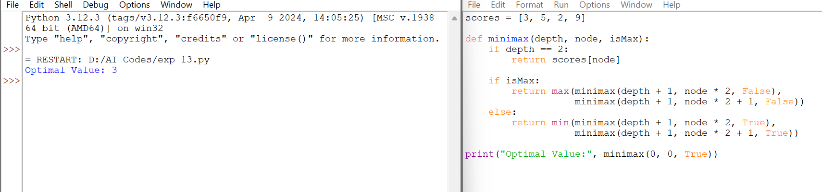

RESULT:
The Python program successfully implemented the Minimax Algorithm. It evaluated all possible game outcomes and selected the optimal move for the maximizing player. The optimal value obtained is 3.

